Execution Of Implementation:

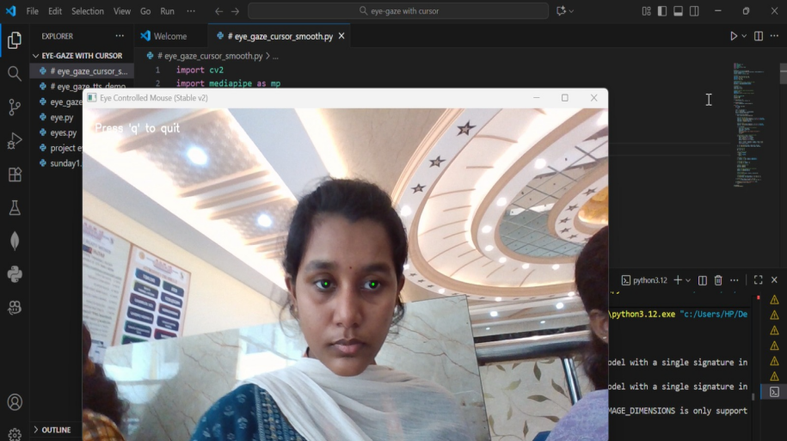

The above image shows the eye gaze detection system that identifies the user’s eye position while looking at the screen. Green markers on the irises indicate accurate iris and gaze point tracking using the Media Pipe Face Mesh model.

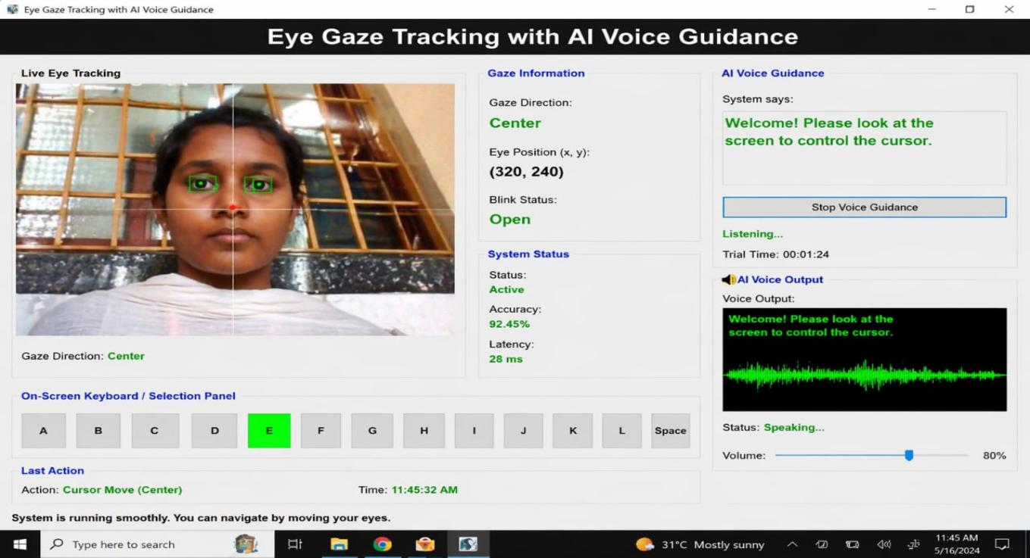

The image shows the system successfully detects the user’s eye gaze direction (top-right) using real-time webcam input and maps it to screen coordinates for interaction. The AI voice guidance provides instant audio feedback and confirms actions.
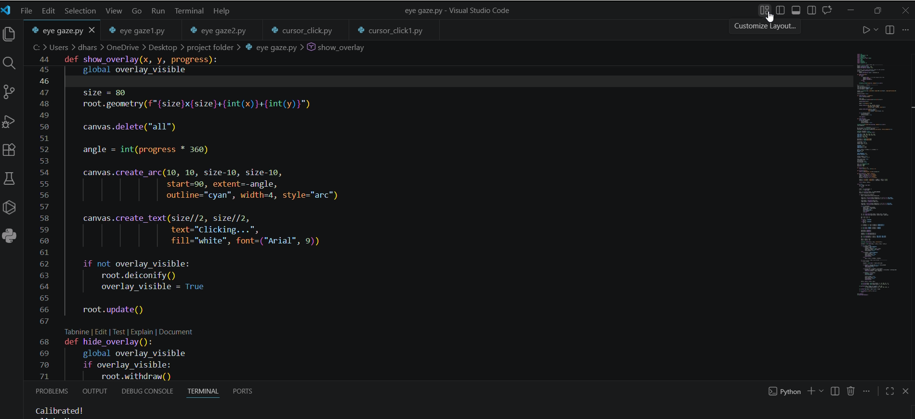

The image shows a Visual Studio Code window where the “Customize Layout” option is being selected using an eye gaze–controlled cursor. When the user focuses their gaze on the layout icon, the cursor moves precisely to that point without using a physical mouse.

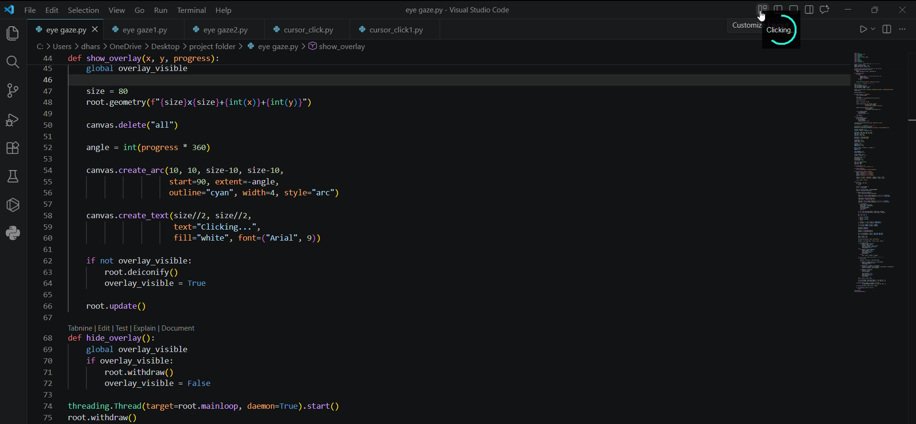

The image shows a floating overlay indicator that appears near the cursor during gaze-based interaction. This overlay is a small circular UI element displaying a progress arc along with the text “Clicking…”, indicating that the system is preparing to perform a click action.
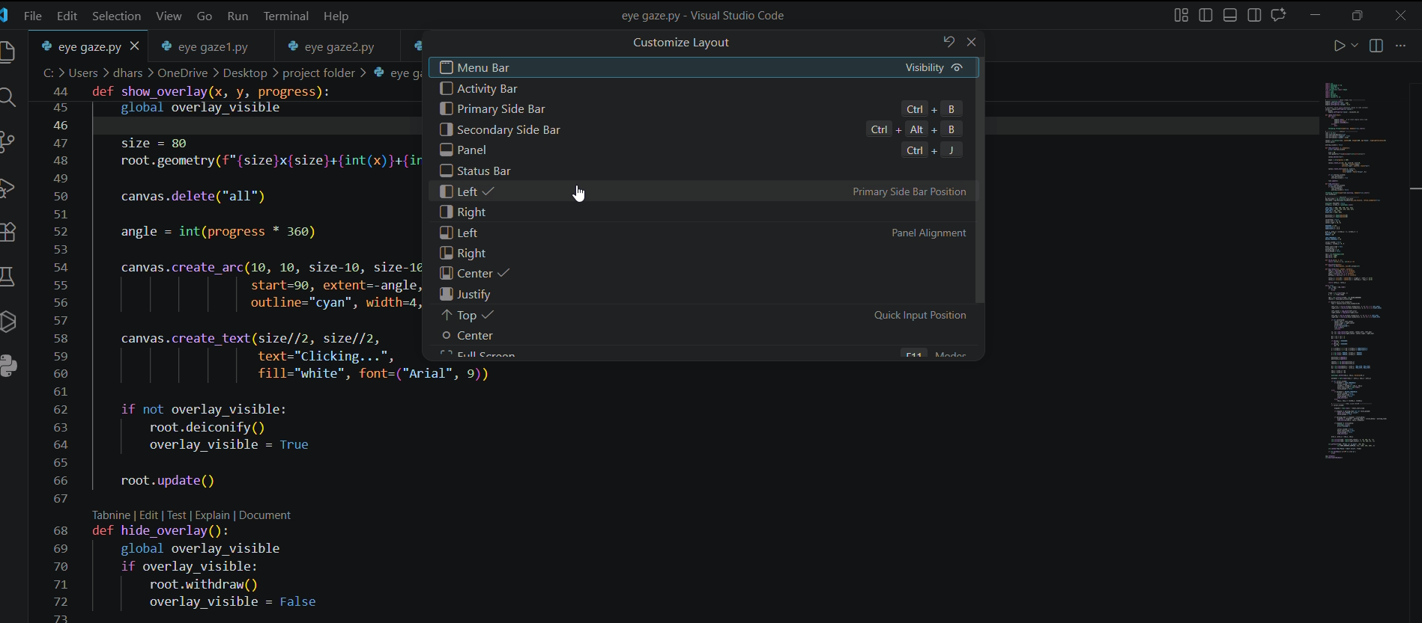

The image shows the Customize Layout menu in Visual Studio Code after it has been selected using the eye gaze–controlled system. The cursor, controlled by iris movement, successfully navigates and opens this dropdown without physical input.

